**ALAGAPPA COLLEGE OF TECHNOLOGY**

**ANNA UNIVERSITY-600025**

**NAAN MUDHALVAN ASSIGNMENT**

**DIGITAL MARKETING**

**Name:** Hananiah Shadrach D

**Roll No:** 2020308011

**Department:** B. Tech Pharmaceutical Technology

**College:** Alagappa College of Technology, Anna University.

**Naan Mudhalavan ID:** E42CBE19524F147BAC44ECDAB8F47E5A

**Zone:** Zone-1

**Assignment-1:**

Create a company name and design a poster and logo for that company.

Company Name: Akatsuki

Company Description: The Shining Dawn

Company Type: Restaurant

Logo:



Poster:

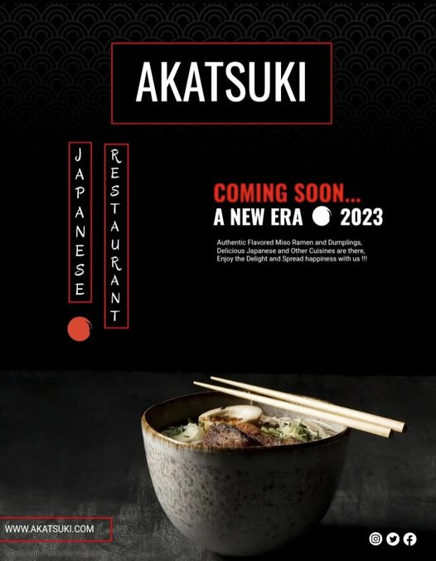

**Assignment-2:**

Create a blog describing about your company.

Blog Link:

<https://akatsukitherestaurant.blogspot.com/2023/08/immerse-yourself-in-anime-bliss.html>

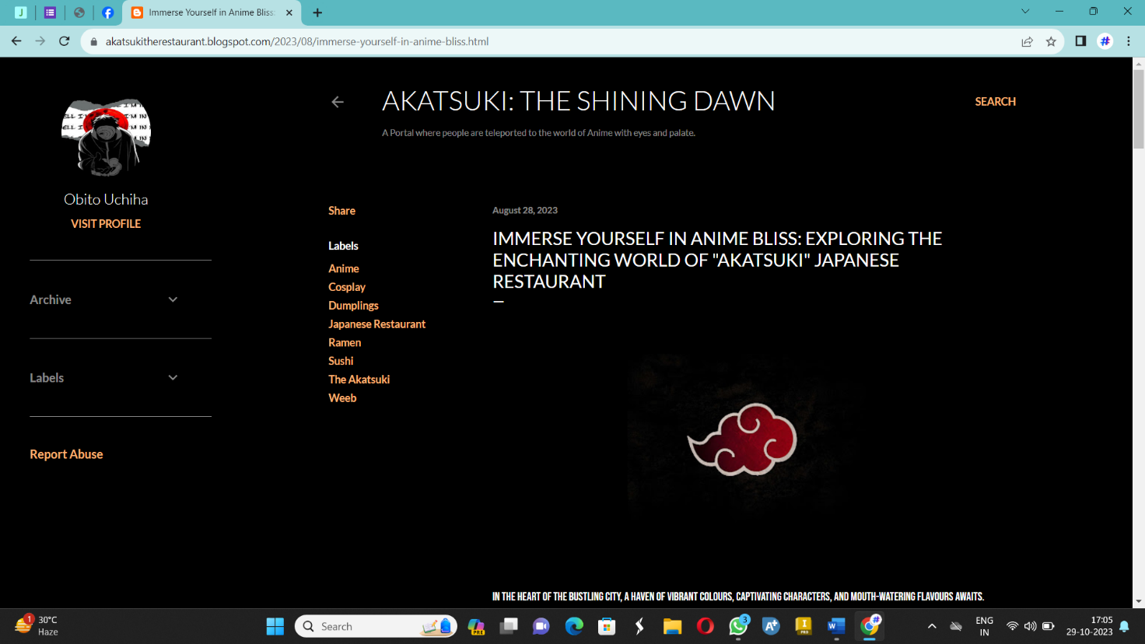

**Assignment-3:**

Create a Facebook account for your company

Facebook ID:

<https://www.facebook.com/profile.php?id=61550336020342&mibextid=9R9pXO>

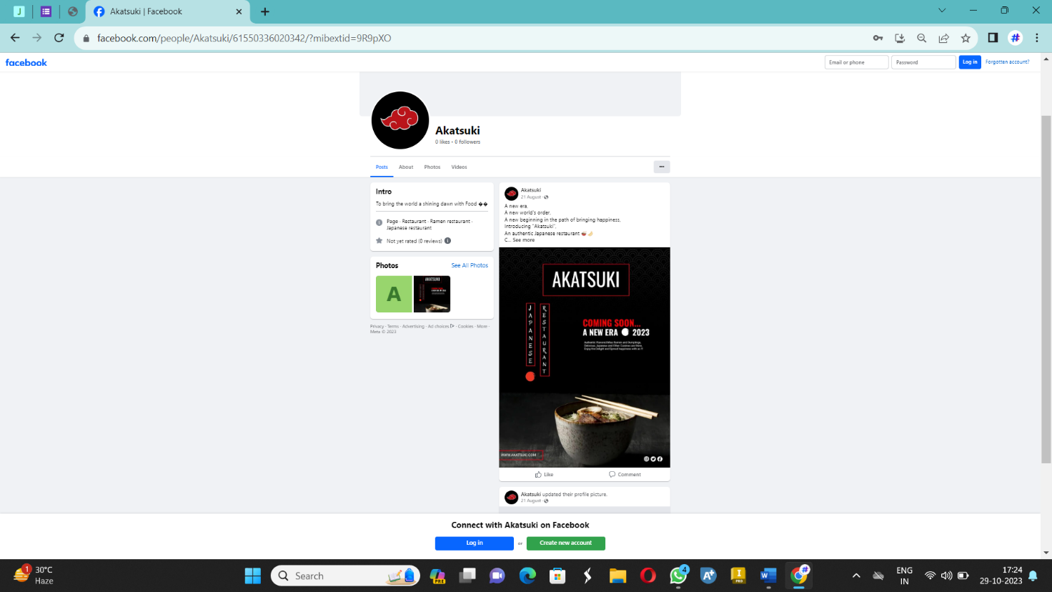

**Assignment-4:**

Create an Email Newsletter for your company and post it in your company blog site. Do google analytics for you blog and send google analytics id.

Google Analytics ID: G-LQM46V6PSY

Email Newsletter link:

<https://akatsukitherestaurant.blogspot.com/2023/09/blog-post.html>

Email Newsletter:

